Link Logistics International
Unit 3, 4 Sinclair Place
Cambridge TAS Australia 7170
Ph: 03 6248 3100

Container Inspection Checklist

Date: |  | Checklist completed by:

Container: |  | Container Size / ISO Code:
Seal: |  | Facility:

7 Point Checklist | Pass / Fail – Comment as req | Description | Yes / No – Comment as req
1.Outside / Undercarriage |  | Free from damage
2.Inside & Outside Doors |  | Clean & free from pests
3.Right Side |  | Free of odours
4.Left Side |  | Structurally sound
5.Front Wall |  | Door seal intact
6.Ceiling / Roof |  | Doors closed
7.Floor (inside) |  | Seals intact

Export Containers
Date of Loadout
Time of loadout – Start to Finish
Establishment #
RFP #
Transfer Certificate #
Destination Country
Product/s
Consignment / Reference #
Refrigeration (if applicable)
Unit operating at time of loadout
Set point
Vents
Product temperature
Data logger number (if required)

Loadout supervised by: |  | Signature: |  | Date:
Ceiling / Roof
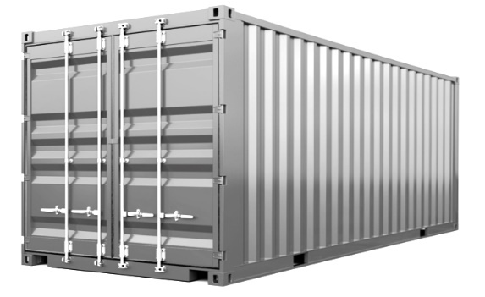
Front Wall
Left Side
Right Side
Inside / Outside
Doors
Outside / Undercarriage
Floor (Inside)
Link Logistics International
Unit 3, 4 Sinclair Place
Cambridge TAS Australia 7170
Ph: 03 6248 3100

Container Weight Declaration

Chain of Responsibility

The consignor or a person who offers a container for transport by road must prepare a container weight declaration (CWD) and give a copy to the road transporter or driver before the commencement of the container’s road journey. All information provided should be true and correct.
I |  |  |  | of
 | Full Name |  |  |  | Company Name

Address

Declare the following information to be true and correct
20’ GP ☐ | 40’ GP ☐ | 40’ HC ☐ | 20’ RF ☐ | 40’ RH ☐ | Please Tick

Container Number

Container Seal

Container Tare Weight

+ Cargo Gross Weight

= VGM (Verified Gross Mass)

Sign |  | Print |  | Date

